**Virtualization:**

Virtualization creates a virtual version of underlying services, enabling multiple operating systems and applications to run simultaneously on the same hardware, improving utilization and flexibility.

Network Virtualization:

* Network virtualization creates multiple virtual networks on a shared physical network, improving hardware usage and efficiency.
* It isolates different workloads, offering flexibility in network management and enhanced security by separating virtual networks.
* Components like switches, routers, firewalls, and VPNs can be managed independently from the physical network, making network provisioning easier.

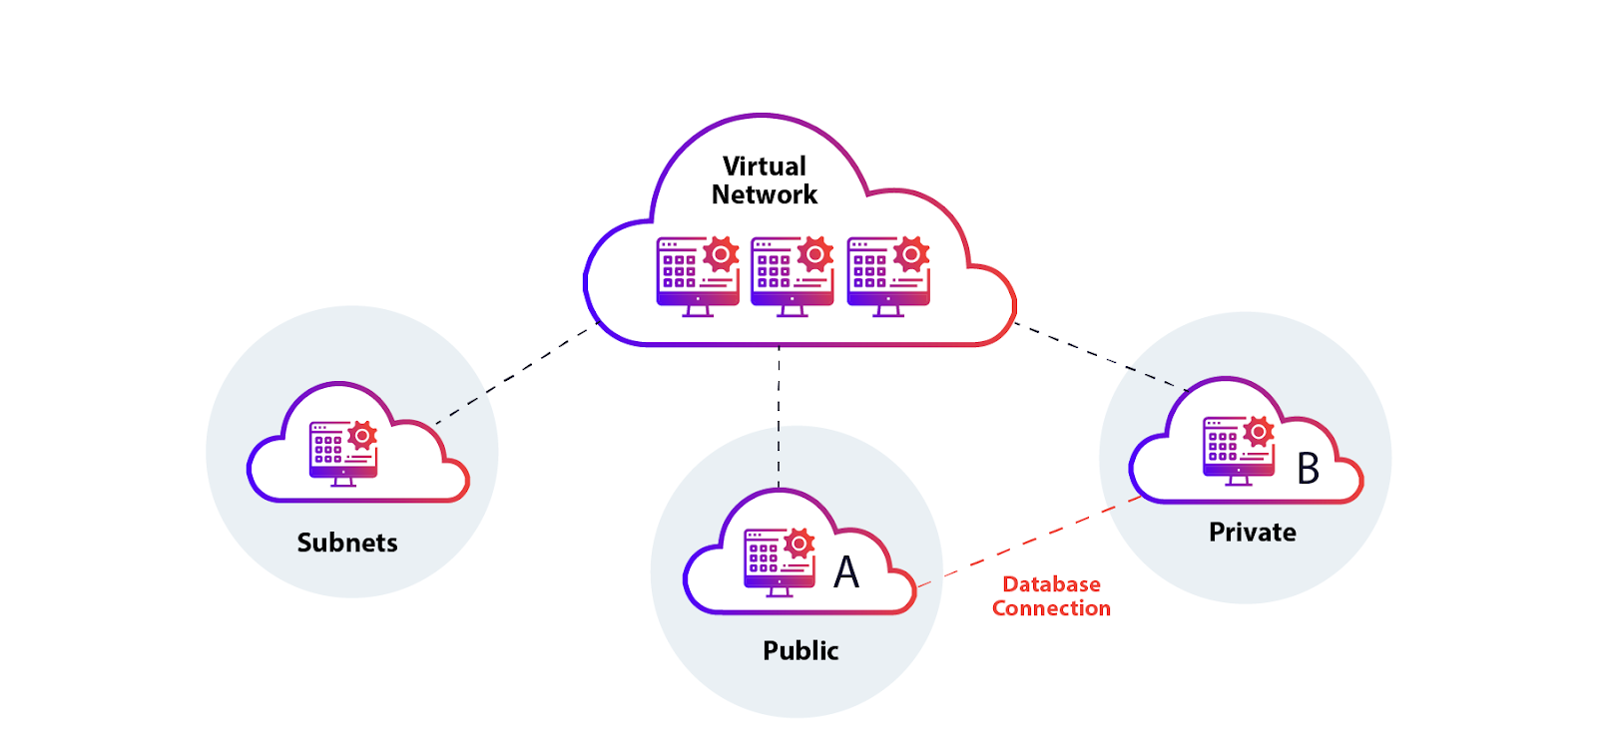

Key Components of Network Virtualization:

1. **Virtual Network Functions (VNFs)**:  
   VNFs are software-based network functions that replace traditional hardware appliances like routers and firewalls, offering flexibility and scalability.
2. **Virtual Switches**:  
   Virtual switches enable communication between virtual machines (VMs) within a virtual network, independent of physical switches.
3. **Virtual Routers**:  
   Virtual routers route traffic between different virtual networks, ensuring proper data flow across isolated environments.
4. **Virtual Firewalls**:  
   Virtual firewalls control inbound and outbound traffic within virtualized networks, providing security by allowing only authorized traffic.
5. **Virtual Private Networks (VPNs)**:  
   VPNs ensure secure communication between virtual networks or external networks, protecting data confidentiality and integrity.

Types of Network Virtualization:

* **Overlay Networks**:  
  Overlay networks create virtualized networks on top of physical networks using tunneling protocols like VXLAN or GRE to encapsulate traffic.
* **Software-Defined Networking (SDN)**:  
  SDN separates the control plane from the data plane, enabling centralized software-based management of network resources for greater flexibility.
* **Network Functions Virtualization (NFV)**:  
  NFV replaces hardware appliances like firewalls and load balancers with software-based network services running on standard servers.

Benefits of Network Virtualization:

* **Increased Flexibility**:  
  Virtual networks can be easily created, modified, and deleted, allowing faster responses to business needs and simplified management.
* **Cost Savings**:  
  By virtualizing networks, organizations reduce costs by consolidating hardware and using software to manage resources.
* **Scalability**:  
  Network virtualization allows for easy scaling of network resources without disrupting existing infrastructure.
* **Enhanced Security and Isolation**:  
  Virtual networks can be isolated from each other, improving security by preventing interference between workloads or users.

Challenges of Network Virtualization:

* **Complexity**:  
  The setup and management of virtualized networks can be complex, especially when integrating with legacy systems or third-party tools.
* **Performance Overhead**:  
  Virtualized networks may experience performance overhead due to additional layers of abstraction compared to physical networks.
* **Compatibility and Integration**:  
  Integrating network virtualization with existing physical infrastructure and legacy systems can be challenging.